County of Lethbridge Junior High Athletic Association

Revised: March 2019

1. CLASSIFICATIONS

There are two classifications for both boys and girls.
(Junior and Varsity)

2. ELIGIBILITY

2.1 Varsity - Any student from Grades 7, 8 or 9.
2.2 Junior - Any student from Grades 6, 7 or 8.

Exception: Schools are to make a yearly declaration if they wish to use grade 6 students or have floaters who play on both Varsity and Jr. teams. This declaration will be made clear on the submitted rosters.
Floaters: Four grade 7 or 8 floaters can be used to field a team. They are able to play the entire game and must be included on the roster.
If exceptions need to be made due to lack of numbers, teams will have to apply to the commissioner to exceed Four floaters.

  - The COLJHAA follow the zone guidelines regarding the use of Grade Five players at the Junior High level of competition. (1J schools).

3. SEASON

The season of play will commence on the Monday following the COLJHAA volleyball season and end by the second weekend in March.

4. COMPETITION

4.1 Varsity and Junior

    - A league consisting of no less than one game with each of the other member schools in the league will be played.

    - If a school has more than one team in any division, the teams should be of “equal calibre”.

    - All teams will participate in the year-end tournament. If the number of teams exceeds eight then teams may have to participate in a qualifying round that would guarantee only one game to teams losing in this round. Game in the qualifying round will be included in the year-end tournament. The team eliminated in the 8 vs. 9 basketball playoff game shall receive ½ of the entry fee back.

    - The eighth and ninth place teams will play their game on the Friday of the post-season tournament.

    - The COLHJAA has established a five, six, seven, eight and nine team tournament draw which it is expected that hosting schools will use (see attachments).

    - The year-end tournament will be held the week prior to Zone competition, unless circumstances make this an impossible venture.

    - In the situation where there are more players and coaches than medals in the playoff tournament, the chair becomes responsible for ordering more and the cost is billed to the tournament.

    - For 3J reps (boys and girls): Separate playoff dates will be set to complete a format for the number of teams that have declared. The formats will be the ones set out in the handbook. The dates will be weekdays between the Tuesday before JV LCT’s and the Friday before SV LCT’s.

    - For 2J reps (boys and girls): The LCT will be used to determine the zone reps.

    - For JV Girls, move the free throw line closer to the basket by 2 feet (60 cm).

    - All teams are committed to playing ALL of the games that are scheduled. Cancellations must be approved by the league commissioner. Any concerns must be addressed to the commissioner.

    - All COLJHAA final basketball tournaments will be an 8 team draw. If there are more than 8 teams, playoff games will be scheduled. All playing games must be played prior to the Thursday leading up to a weekend tournament.

5. AWARDS

  - Varsity & Junior

5.1.2 Each member of the 1st place, 2nd place, and 3rd place teams in the final tournament will receive a medal. The winning team will be awarded a COLJHAA banner while the 2nd place team will receive a plaque.

6. RULES

The current rules of FIBA as adopted by the ASAA, with modifications will be used Modifications see Appendix A.

7. SCORE SHEETS

7.1 The attached score sheet is recommended for use in our schools.
See Appendix B (attachment which came with this document).

7.2 The host school shall enter the game scores onto the league results web-page within 24 hrs of the completion of the game. http://www.coljhaa.com/
7.3 The League Chair will invite the AD at each school to edit the results google doc on the website.

8. REFEREES

8.1 Referees do not have to be carded, but it is recommended that at least they partake in a course that allows for referees to become familiarized with league rules and expectations.
8.2 The league further recommends that each officiating pairing should include at least one adult.
8.3 League Commissioner will organize an annual ‘pre-season’ referee clinic. Each member school is advised to send representatives.

9. RESPONSIBILITIES OF HOST SCHOOL

  - PROVIDE TRAINED (competent) personnel to run the clock and keep the official score.

  - To provide qualified referees, one of which should be an adult.

9.3 Provide all necessary supervision in the gymnasium and hallways.

10. SIZE OF BALL

(PLEASE NOTE THIS ITEM)
All teams use a size 6 ball (JV Boys and Girls and SV girls) except Varsity Boys use size 7.

11. OVERTIME

A three-minute overtime period will be played at the Varsity level if the score is tied at the end of regulation time. There will be a one-minute break before starting the overtime. Each team will be allotted one time out per overtime period. Overtime will continue until the tie is broken.

A three-minute overtime period will be played at the Junior level if the score is tied at the end of regulation time. There will be a one-minute break before starting the overtime. Each team will be allotted one time out per overtime period. At the end of the 3 minute overtime period, if the score is still tied, additional OT periods will continue until the tie is broken.

12. TIE BREAKING PROCEDURES

12.1 The tie breaking procedure shall only be utilized to determine seeding for the final playoff tournament.

12.2 League standings shall be based upon the over-all win/loss record. If in compiling these a tie occurs, the following procedure shall be applied:
a. Results of games between the teams that are tied.

b. Points for and against in the game(s) between the teams that are tied.

c. Points for and against throughout the entire league play.

d. If the tie still is not broken, a coin toss conducted by the chairperson, with a witness, shall be done.

13. PLAYERS AND COACHES CONDUCT

13.1 It is expected that all players and coaches are to represent themselves in a manner that reflects positively on the individual, the school, and the C.O.L.J.H.A.A.

13.2 The responsibility for control of the game is ultimately the referees. However, the C.O.L.J.H.A.A. wishes to assist the referees in ensuring that athletes and coaches who consistently represent themselves in a poor manner are dealt with quickly and with specific consequences:

- Players and Coaches Conduct – See Appendix C.

14. TIME OUTS

- Time-outs – 2 in first half, 3 in second (FIBA recognizes three in second). To be requested at the scorekeeper’s table by the coach … To be granted at next stoppage of play, or if scored upon.

- If a timeout is called in the last two minutes of the 4th quarter or each overtime period, the ball is advanced to the center line (straddle – allows throwing into backcourt).

Appendix A

EXCEPTIONS TO F.I.B.A. RULES

- Junior shall consist of four 8 minute stop time quarters. Senior shall consist of 4 10 minute stop time quarters.
Half time shall only be 5 minutes, while quarters shall be 1 minute.

- A 16’9” 3 point line will be used (measure from the center of the hoop) for the juniors. The seniors will use the regular high school three-point line (which may not be consistent with the FIBA regulations).

- There will be no visible 24 second clock. However, if referees feel that a team is stalling, they will give a 10 second warning. If no ‘shot’ (must hit rim) is taken, the ball will be awarded to the opposing team.

- The junior girls’ foul line will be at 11’9” (2 feet shorter – measured from the center of the hoop).

- “Mercy Rule”. Seniors may press the entire game, unless there is a 20 - point differential; at which time, the team with the lead may not press. ().

Juniors may only press with 5 minutes left at the end of the second and fourth quarters; again, the “mercy rule” will apply; however, the point differential only needs to be 15. If a team has been cautioned and further violations follow, an unsportsmanlike foul / technical (2 shots) will be applied.

- Five full time outs will be permitted during the game: two in the first half and three in the second. The coach is required to call these through the scorekeeper’s table (in advance of a dead ball situation). Timeouts can only be called during a stoppage of play! If a timeout is called in the last two minutes of the 4th quarter or each overtime period, the ball is advanced to the center line (straddle – allows throwing into backcourt). A coach may call a time out simply to substitute players (FIBA mandates that a team must remain in the huddle for 50 seconds…).

- Any team representative who receives two direct technicals will have to sit the next game. (Referee is required to fill out Technical/Disqualifying Foul Report).

Appendix A
Rules of Play/Guidelines for COLJHAA

- After the initial toss, any jump ball will be an alternating possession, including overtime.

- COLJHAA JV division teams ‘must’ use a Man-to- Man defense. JV team not using a Man-to-Man defense will be given a verbal warning for the first infraction. Should a second infraction occur, the team will be served with a bench technical which will be levied against the coach.

- When the referee calls ‘set’ (‘ball going up’), players are allowed to move around the circle prior to the toss (not onto or into the circle).

- During a throw-in, the ball is not allowed to go from the front court to the back court, unless the player has straddled the center line (players should be encouraged to ask the referee if the backcourt is available).

- During a throw-in, the inbounder is permitted to move laterally up to 1 meter.

- Violation of either team during a free throw does not affect the shooter’s right to complete the free throw… (shooter has 5 seconds to shoot).

- Lane spaces may be vacant during a free throw.

- After a made free throw, where the shooter is in violation, the basket does not count and the defending team is to inbound the ball at the sideline (foul line extended).

- Shooter is considered to be in the act of shooting until both feet have touched the floor.

- A blocked shot that remains in the possession of the shooter is considered to be a travel (not a jump ball). However, if an offensive and defensive player both have a firm grip on the ball, it is then considered to be a jump ball.

- Player with the ball is permitted to fall (not considered to be traveling). However, a player on the ground is not permitted to stand up, unless he/she initiates their dribble while on the ground.

- A team is permitted four fouls per quarter before the team foul penalty (two shots, no bonus situation) takes place. Team fouls equals all player personal and technical fouls (technical fouls on coaches, assistants, etc. are not team fouls). The fourth quarter fouls carries over to the overtime periods.

- Technical foul – non-contact fouls on live or dead ball – penalty is 2 shots plus possession at the center line (straddle).

- Ball is permitted to pass over the backboard in either direction, provided it does not contact any of the supports.

- Player is permitted to rebound their own missed shot (even if it is an air ball, if the referee judges that it was a try for goal).

Special Rules for the last 2 minutes of the 4th quarter and each subsequent overtime period.

- Game clock stops on every whistle. The only exception to this is a made basket in the last two minutes of the 4th quarter and each overtime period.

- Substitutions – permitted during clock stoppage, and only prior to the first free throw. During the last two minutes of the 4th quarter, subs are permitted for the team that has been scored upon (at which time opponents may sub as well – subs need to be at the scorer’s table…).

Appendix B

COLJHAA SCORE SHEET

Please see attachments for the Excel Document for the ASAA Fiba Score
sheet named “ asaafibascoresheetrevised

Appendix C
PLAYERS AND COACHES CONDUCT

PLAYERS

- Any player who receives two technical fouls / two unsportsmanlike fouls (flagrant or hard), or a combination thereof will result in the removal of that player from the game in which they are playing and an automatic suspension from the next game – to be reported to the chairperson as soon as possible after the game.

If this occurs a second time during any scheduled league or playoff game, the player will be referred to the Review Board with the recommendation for an indefinite suspension.

- Any player who receives a combination of two technical / unsportsmanlike fouls in the course of the regular season, which includes the playoffs, will be suspended from the next scheduled game.

If this occurs a second time during any scheduled league or playoff game, the player will be referred to the Review Board with the recommendation for an indefinite suspension.

- Any player who uses profane language on or off the court will be given a technical. This should be reported to the Administration of that player’s school, where it would be expected that appropriate consequences would be administered.

COACHES

1. Any coach who receives two technical fouls, whether this be in a single game or a combination of games throughout the season, will be referred to the Review Board whereupon that coach’s eligibility will be reviewed.

2. Any coach who uses profane language on or off the court will be given a technical. This should be reported to the Administration of that coach’s school, where it would be expected that appropriate consequences would be administered.

Points to Remember

1. If SV, 9th team playoffs against 8th team, Thursday before playoffs at 8th place team’s home or Friday before tournament. Do not move brackets.
2. JV game: Four 8 minute stop time quarters, SV game: Four 10 minute stop time quarters.
3. Time outs are as per FIBA rulebook. The coach must request a timeout at the score table. The timeout will be called on the next dead ball or when when the opposing team scores a basket.
4. 4:00 pm start time for JV then SV to follow @ approx. 5:15 pm.
5. All changes to be submitted to the league chair prior to the first league being played.
6. Refs are usually given $30 per game.
7. $200 entry fee per team. (Regardless of whether JV or SV)

8. Gate charge: $2.00 per student
$3.00 per adult per day
$5.00 tournament pass
Free to elementary student accompanied by an adult

COLJHAA Senior Varsity Basketball Playoffs
5 Team Playoff format
4th
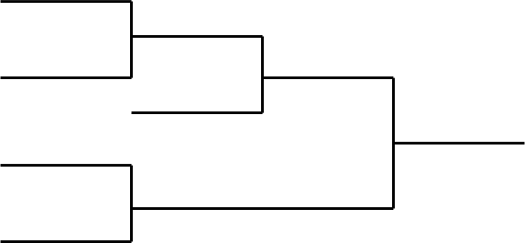
(Game 1)

5th (Game 3)

1st
(Game 6)
2nd
1st & 2nd Place
(Game 2)

3rd

L1

(Game 4)

L2
(Game 5)
3rd Place
L3

6 Team Playoff Format

6 team round robin playoff, using the regular season record for seeding purposes.

Game | Pool | Match up
1 | A | 1-4
2 | B | 2-3
3 | A | 4-5
4 | B | 3-6
5 | A | 1-5
6 | B | 2-6
7 | Consolation | 3rd Pool A vs 3rd Pool B
8 | Third Place | 2rd Pool A vs 2rd Pool B
9 | Championship | 1st Pool A vs 1st Pool B

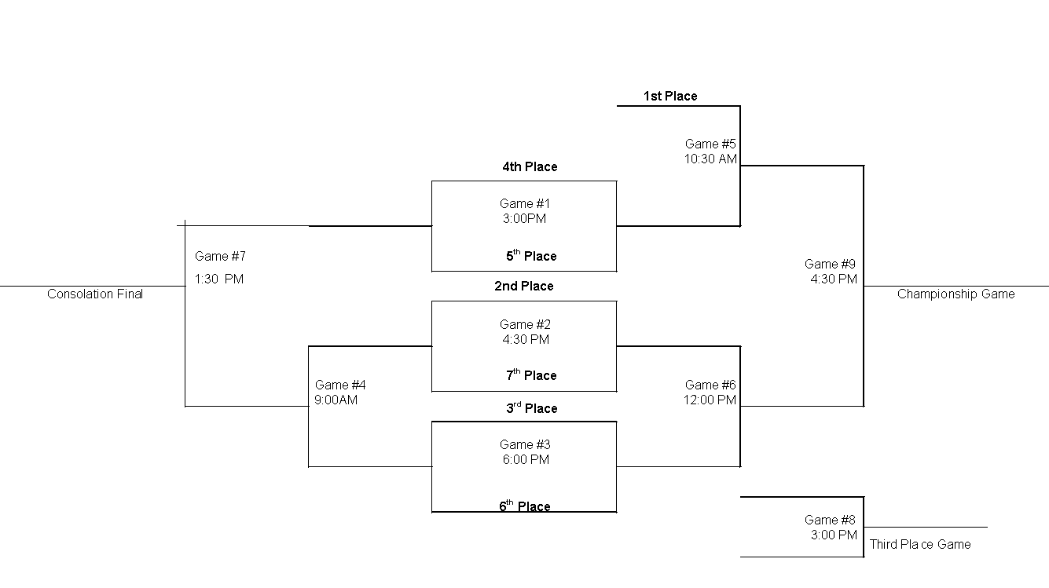
7 Team Play off Format

NOTE: The bottom team on the draw is home, and will wear the light coloured uniform.
GAME # | DAY | TIME | TEAM | VS. | TEAM
1 | Friday | 3:00 p.m. | (4) | vs. | (5)
2 | Friday | 4:30 p.m. | (2) | vs. | (7)
3 | Friday | 6:00 p.m. | (3) | vs. | (6)
4 | Saturday | 9:00 a.m. | Loser # 2 | vs. | Loser # 3
5 | Saturday | 10:30 a.m. | (1) | Vs. | Winner #1
6 | Saturday | 12:00 p.m. | Winner # 2 | vs. | Winner # 3
7 | Saturday | 1:30 p.m. | Consolation Final
8 | Saturday | 3:00 p.m. | Third Place Final
9 | Saturday | 4:30 p.m. | Championship Game

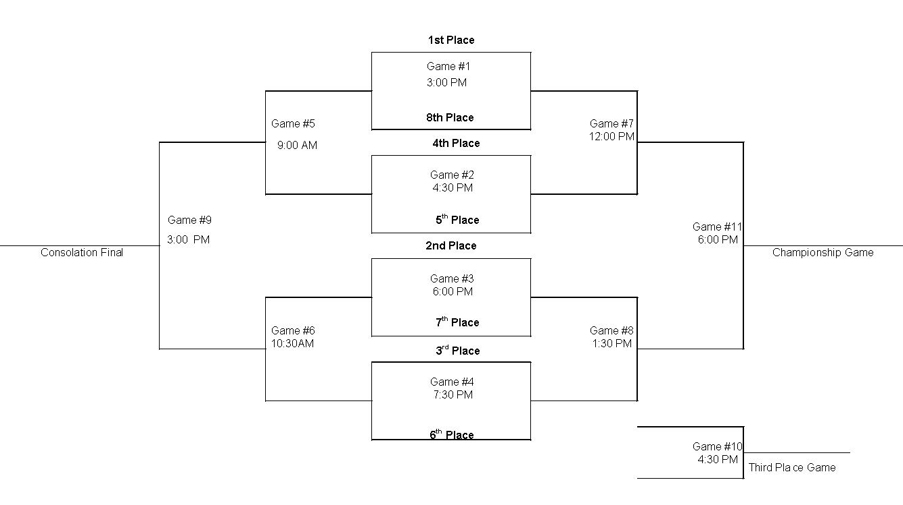
8 Team Playoff format

NOTE: The bottom team on the draw is home, and will wear the light coloured uniform.
GAME # | DAY | TIME | TEAM | VS. | TEAM
1 | Friday | 2:00 p.m. | (1) | vs. | (8)
2 | Friday | 3:30 p.m. | (4) | vs. | (5)
3 | Friday | 5:00 p.m. | (2) | vs. | (7)
4 | Friday | 6:30 p.m. | (3) | vs. | (6)
5 | Saturday | 8:00 a.m. | Loser # 1 | vs. | Loser # 2
6 | Saturday | 10:30 a.m. | Loser # 3 | Vs. | Loser # 4
7 | Saturday | 12:00 p.m. | Winner # 1 | vs. | Winner # 2
8 | Saturday | 1:30 p.m. | Winner # 3 | vs. | Winner # 4
9 | Saturday | 3:00 p.m. | Consolation Final
10 | Saturday | 4:30 p.m. | Third Place Final
11 | Saturday | 6:00 p.m. | Championship Game

PLAYOFF FORMAT

Please refer back to Competition;

4.1.12-All COLJHAA final basketball tournaments will be an 8 team draw. If there are more than 8 teams, playoff games will be scheduled. All playing games must be played prior to the Thursday leading up to a weekend tournament.

